
American Battery Solutions Inc.

SOC Interface Document

Document ID: TBD | Release Date: 07/22/2025
Revision: Initial Version | Owner: ABS

(c) [2019] [American Battery Solutions]; all rights reserved. This document may contain proprietary information and may only be released to third parties with approval of management. Documents are uncontrolled unless otherwise marked; uncontrolled documents are not subject to update notification.

Table of Contents
1 Scope of this Document 2
2 Important Terms 2
3 Functional Overview 2
3.1 Block Diagram 2
3.2 Interfaces 3
3.2.1 Required Interfaces 3
3.3 Configuration 3
3.4 Calibrations 3
3.5 Sequence Diagrams 4
4 Source File List and Description 4
4.1 Below file list implement the functionality of the SOC component. 4
4.2 SOC_Estimation\Model\SOC_Estimation_ert_rtw\SOC_Estimation.mk 4
5 Build and Test 4
6 Integration Procedure 4
7 Resource Consumption 4
8 MISRA + BARR-C 4
9 References 4

- Scope of this Document
This document outlines a detailed description of the SOC model interfaces, high level architecture and calibration parameters.

- Important Terms
Terms | Definition
SOC | State of Charge
OCV | Open Circuit Voltage
BMS | Battery Management System

- Functional Overview
The SOC model integrates multiple estimation methods to improve accuracy and robustness. It includes Coulomb Counting, which calculates SOC by integrating current over time, and OCV-based estimation using voltage-temperature characteristics. A rest time detection block filters battery current to identify stable periods suitable for OCV correction. The SOC correction module blends Coulomb and OCV estimates based on rest time and hysteresis error to produce a refined SOC output. Temperature inputs are also considered to dynamically adjust filter weights and estimation accuracy.

  - Block Diagram
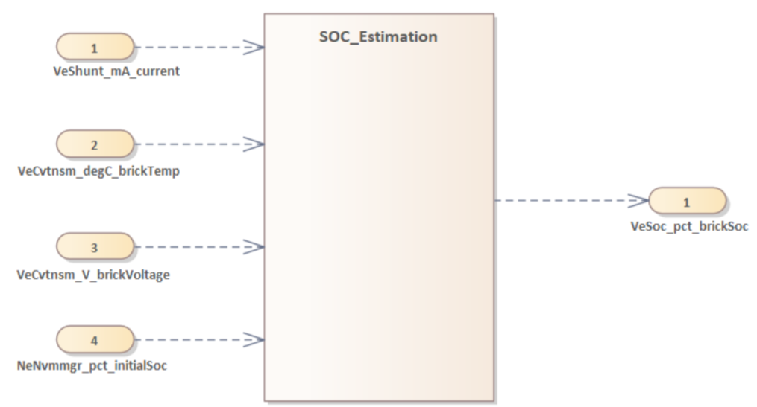

Figure 1: SOC Component Overview Diagram

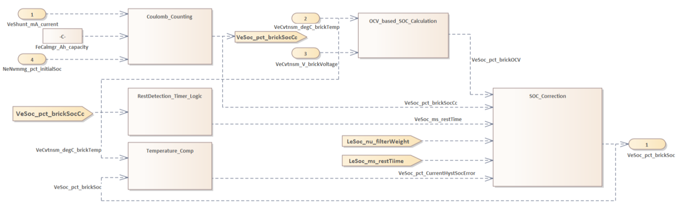

Figure 2: SOC Estimation Simulink Model Diagram

  - Interfaces
The following section will provide more detail on the interfaces of the SOC component.

    - Required Interfaces
Interface | Description
VeCvtnsm_V_brickVoltage | Battery cell/brick voltage used to estimate SOC.
VeShunt_mA_current | Battery current used for Coulomb counting-based SOC calculation.
VeCvtnsm_degC_brickTemp | Cell/brick temperature used for OCV correction and dynamic behavior
NeNvmmgr_pct_initialSoc | Initial State of Charge value for model initialization from NVM.

  - Configuration
Table 1 below lists out the configuration parameters for the component.

Define Name | Description
VeSoc_ms_sampleTime | Constant time interval (in milliseconds) at which the SOC estimation algorithm is executed. Defines the fixed execution rate of the model.
VeSoc_mA_restingCurrent | Constant threshold current (in milliamps) below which the battery is assumed to be at rest, allowing the use of open-circuit voltage (OCV) for SOC correction.

  - Calibrations
Define Name | Description
FeCalmgr_Ah_capacity | Nominal capacity of the battery (in mAh or Ah), used as a reference for SOC calculation via Coulomb counting.

  - Sequence Diagrams
N/A
- Source File List and Description

  - Below file list implement the functionality of the SOC component.
SOC_Estimation\Model\SOC_Estimation_ert_rtw\SOC_Estimation.c
SOC_Estimation\Model\SOC_Estimation_ert_rtw\SOC_Estimation.h
SOC_Estimation\Model\SOC_Estimation_ert_rtw\ert_main.c
SOC_Estimation\Model\SOC_Estimation_ert_rtw\SOC_Estimation_data.c
SOC_Estimation\Model\SOC_Estimation_ert_rtw\SOC_Estimation_private.h
SOC_Estimation\Model\SOC_Estimation_ert_rtw\SOC_Estimation_types.h
SOC_Estimation\Model\SOC_Estimation_ert_rtw\SOC_Calibration.h
SOC_Estimation\Model\SOC_Estimation_ert_rtw\SOC_Calibration.c
  - SOC_Estimation\Model\SOC_Estimation_ert_rtw\SOC_Estimation.mk
This is make configuration file to build the SOC software component.
- Build and Test
N/A (This document is intended for POC)
- Integration Procedure
N/A
- Resource Consumption
Resource | Usage
RAM | TBD
ROM | TBD
CPU Bandwidth | TBD

- MISRA + BARR-C
N/A
- References
N/A

